Project Report

Project Title:

Secure Banking Management System

Project Overview:
The Secure Banking Management System is a console-based C program designed to simulate real-world banking operations. The system allows bank users to manage their accounts securely, track transactions, and analyze their spending. Bank administrators can manage accounts, monitor transactions, and resolve disputes. The system emphasizes security, persistence, and usability, making it suitable as a professional internship project.

Problem Statement / Real-World Problem it Solves:
In real-world banking, managing multiple accounts, tracking transactions, and resolving disputes can be challenging without secure and automated systems. This project addresses the following problems:
- Manual account management: Users and administrators struggle to track balances, transfers, and transactions efficiently.
- Security concerns: Unprotected systems can lead to unauthorized access or fraud.
- Transaction disputes: Lack of a formal dispute management system can delay resolution and user satisfaction.
- Financial analysis: Users rarely get insights into their spending habits without analytics.
The Secure Banking Management System solves these problems by providing:
- Secure login with password hashing and automatic lockouts.
- Complete transaction management (deposit, withdraw, transfer).
- Persistent storage of accounts, transactions, and disputes.
- Admin panel for account monitoring and dispute resolution.
- Spending analytics to help users manage their finances.
Objectives:
- To create a secure and persistent banking system using C programming.
- To simulate real banking features like deposit, withdrawal, transfer, and transaction history.
- To provide administrators full control over accounts and disputes.
- To implement data persistence, so the program retains all account and transaction history between sessions.
- To showcase coding best practices for file handling, structures, and modular programming.
- To create a professional, user-friendly console UI suitable for demonstrations or interviews.

Programming Language & Tools:
- Language: C
- Compiler/IDE: GCC / VS Code
- Files Used:
  - accounts.dat – Stores account details
  - transactions.dat – Stores transaction history
  - disputes.dat – Stores disputes
  - audit.log – Stores system logs for auditing

Features:
User Features:
- Account Creation: Users can create accounts with unique IDs, usernames, and secure hashed passwords.
- Login/Logout: Secure login with password hashing and lockout after three failed attempts.
- Deposit Money: Users can deposit money into their accounts with category tagging.
- Withdraw Money: Withdrawals include a daily limit of ₹20,000 and fraud alerts for large transactions.
- Transfer Money: Users can transfer funds to other accounts.
- Transaction History: Users can view all previous transactions with timestamps and categories.
- Analytics: Spending analysis by categories such as Food, Bills, Travel, and Others.
- Raise Dispute: Users can report transaction errors or issues.
- View Disputes: Users can track the status of their disputes.

Admin Features:
- Admin Login: Secure access with username/password.
- View Accounts: Display all accounts with balance and status.
- Lock/Unlock Accounts: Manage access for security or policy compliance.
- Remove Accounts: Permanently remove accounts while retaining transaction history.
- View All Transactions: Full transaction logs for auditing.
- Resolve Disputes: Update dispute statuses from pending to resolved.

Security & Data Integrity:
- Passwords are stored using a simple hashing mechanism for security.
- Failed login attempts are tracked, and accounts are automatically locked after three failures.
- Daily withdrawal limits prevent over-withdrawal.
- Large withdrawals trigger a fraud alert for safety.
- All data is persistent in .dat files for continuity.

User Interface:
- Professional console-based menus
- Clear instructions, prompts, and confirmation messages
- Color-coded alerts and notifications (optional in terminal)
- Organized dashboard for users and admins

Usecase diagram:
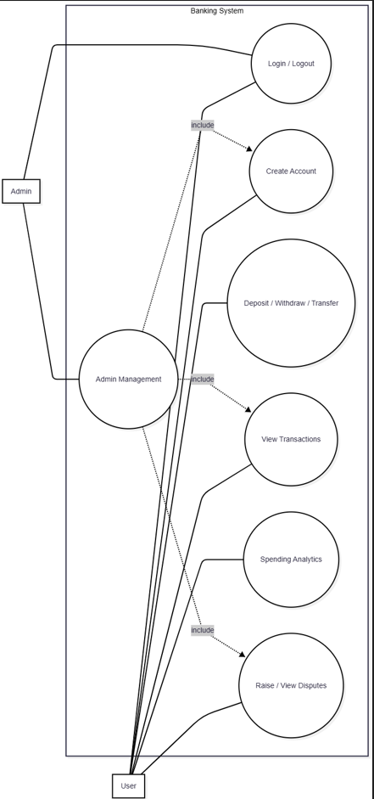

Project Workflow:
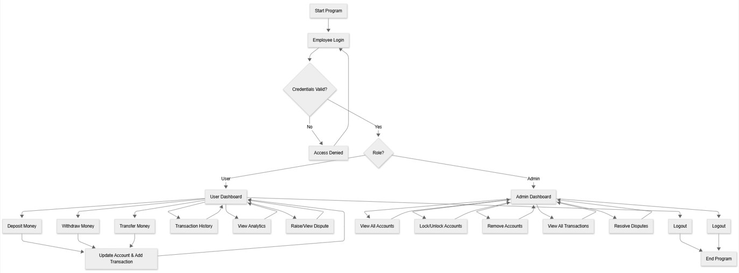
1. Program Start:
===== BANKING SYSTEM =====
1.Login
2.Create Account
0.Exit
2. User Actions:
- Create Account → Login → Deposit/Withdraw/Transfer → Transaction History → Analytics → Raise/View Disputes → Logout
3. Admin Actions:
- Admin Login → View Accounts → Lock/Unlock Accounts → Remove Accounts → View Transactions → Resolve Disputes → Logout
4. Data Persistence:
All accounts, transactions, and disputes remain stored between program runs.

File Structure:
All in one C file: banking_system.c
Data files:
- data/accounts.dat – Account information
- data/transactions.dat – Transactions
- data/disputes.dat – Dispute records
- data/audit.log – System logs

Technical Concepts Used:
- Structures (struct) – For account, transaction, and dispute representation.
- File Handling – Read/write binary files for persistence.
- Functions & Modularity – Separate functions for login, deposit, withdraw, transfer, dispute management.
- Password Hashing – Simple hash for security demonstration.
- Date & Time Handling – Track transaction timestamps and daily limits.
- Console UI – User-friendly dashboard and menus.
- Error Handling – Input validation and account lock mechanisms.

Improvements over Basic Banking Programs:
- Complete admin panel for account and dispute management.
- Daily withdrawal limits and fraud alerts.
- Persistent storage and audit logging.
- Spending analytics for users.
- Transfer between accounts.
- Professional console-based UI.

Applications & Use Cases:
- Internship projects to demonstrate practical C programming skills.
- Resume showcase: Full banking system with admin panel and security features.
- Learning project: Understanding file handling, data persistence, and security in C.
- Simulated banking operations for educational purposes.

Conclusion:
The Secure Banking Management System is a fully functional console-based banking program with user and admin roles, secure login, transaction management, dispute resolution, analytics, and persistent storage. It demonstrates key programming concepts in C, including data structures, file handling, modular design, and basic security mechanisms.

References (Optional):
- C Programming Language – Kernighan & Ritchie
- File Handling & Data Structures Tutorials
- Banking system design concepts

